**What a face says**

* **sentiment classification on facial and linguistic expressions**

Embodied and Situated Language Processing Project

Gothenburg University 2017

Ida Rørmann Olsen, gusrrmid@student.gu.se

*This project is on sentiment classification: sentences are mapped with facial expressions to explore whether a combination would improve classification performance. The idea is that people have certain facial expressions when expressing certain content. Such a model would benefit situated language systems by providing knowledge on sentiment - what faces say. Three classification experiments are done: on facial expressions, on linguistic expressions, and combined. The image data features are extracted from a pre-trained CNN, plugged-in as last layer. A LSTM is trained on the linguistic expressions, and on a combined input of the sentences and images. The results show that combining the input in this setup does not help. This could be due to the data chosen. Further work on more and other data could continue the initial steps that this project has made towards a situated language system able to classify sentiment from visual and linguistic input.*

*1. Introduction*

Sentiment analysis is a hot topic in NLP, and lots have been done to develop systems to decide a sentiment score on natural language expressions. An exploration of whether (or how) visual data can improve this process is not only interesting for wondering language technologists: knowledge of e.g. what faces goes with certain linguistic expressions can 1) hopefully smoothen human-machine interaction in robotics, (situated language systems) 2) possibly help e.g. autistic patients to map between linguistic   
  
expressions, faces and feelings, and 3) probably contribute to the work on detecting sarcasm (or lies or .. ), if a face doesn’t match an expression.

This project combines categories of facial expressions with sentiment scores for natural language sentences. More specifically, it is an implementation to explore the possibility of predicting a sentiment category learned on a bunch of sentences associated with a group of images with certain facial expressions.

The question is whether adding visual data to the language data will improve the sentiment prediction.

The steps in the present work is to:

1. (manually) pair the sentences with the chosen facial expression – building a synthetic dataset
2. Save the sentiment score of the applied sentences. Convert from nominal to categorical
3. Build 3 models (LSTM): language only, faces only, and fit the pairs of sentences and faces with the sentiment category (several experiments)
4. Evaluate

In section 2, the toolkits, methods and decisions throughout the experiment is described. In section 3 the results are presented, and will be discussed in section 4. Finally, section 5 gives concluding remarks and ideas for future improvement and work with the data.

*2. Materials and methods*

The visual data (D.L. Goodfellow et al. 2013) is 48x48 pixel grayscale images of faces labelled with the seven universal facial expressions: angry, disgust, fear, happy, sad, surprise, and neutral. The dataset consists of around 33.000 images.

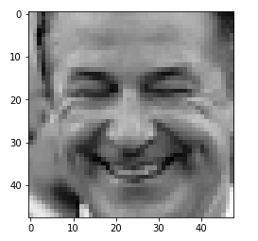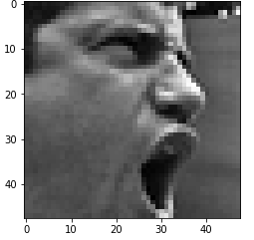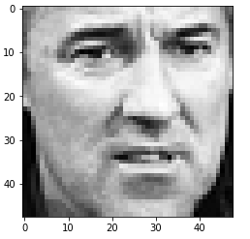

Images from the happy and angry category

The features from this data is extracted with the VGG16 architecture [1] (with several convolutional blocks) that is pre-trained on ImageNet dataset. Weights from the data is added at the final fully-connected layer here.[1]

The linguistic data (Richard Socher et al. 2013) is the classic set of movie review tweets from *Stanford Sentiment Treebank*, labelled with a sentiment score from 0 to 1 (from negative to positive). It includes 215,154 phrases, but I included only the longest 150,000.[2] The sentences from the linguistic dataset was tokenized, lemmatized, lowercased. Keras was used to embed the sentences.

The neural network is build with the Keras package (Francois Chollet et al. 2015) in Python3. See attached Jupyter notebook.

Pandas (Wes McKinney 2010) and NumPy (Stéfan van der Walt 2011) was applied for pre-processing and data handling.

The LSTM (Hochreiter & Schmidhuber, 1997) is a kind of a recurrent network, that can “remember” and keep information previously seen in internal “long-term memory” states. This stored contextual information influence the current predictions, which results in a mechanism that *“[…] allows RNNs to exploit a dynamically changing contextual window over the input sequence history”.*(Hassim Sak, et al., 2014)

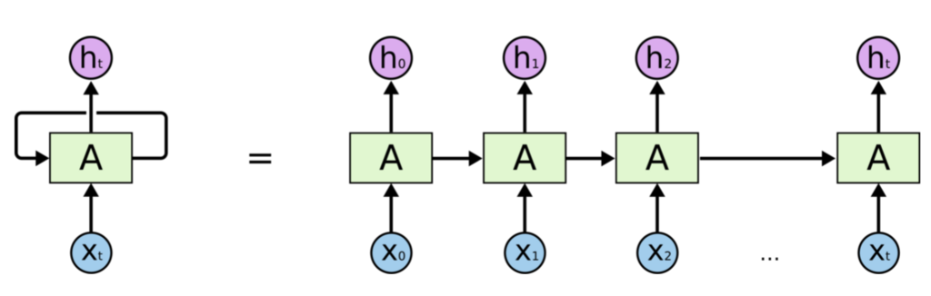

Firstly, I mapped the negative and positive sentences with the angry and happy faces, respectively. I named the classes *negative* and *positive*. The language data sets the upper limit (in size), so every sentence from category X was paired with a random image from category X. The resulting data is 39,200 triplets which consists of sentences, the images and sentiment category.

Additionally, I tested a model build on data including only the *positive* and *negative* class. This results in 20,020 data points, and the train/test split is 80/20 in both cases.

Secondly, I changed the machine learning method to a transfer-learning task: a model was made exclusively from the language data, and then used as a layer in the above-mentioned network. The motivation for this is that it might speed up training and performance – if it finds a pattern in the language, even though it does not in the images. The mapping stayed the same.

Visual and language data as inputs to a system is not rare, but this is a special case: The technique is not image captioning, (since the goal is not describing the input images), nor is it a typical Q&A, since the LSTM model is not trained on question-answer pairs, but pairs of sentences and images. There is a right answer though, a sentiment score (categorical), which is to be classified.[3] The data can be used for several purposes, see discussion in section 5.

The hypothesis is that pairing the sentences and their sentiment scores with the images of different categories of facial expressions will confuse the sentiment prediction (experience show). Will a model perform better by combining this visual data and this language data?

*3. Results*

An improvement of the accuracy with a combination of this visual and language data would be possible if the model found a pattern within the two categories, *positive* and *negative*, in the sentences, as well as in the images. This was not the case:

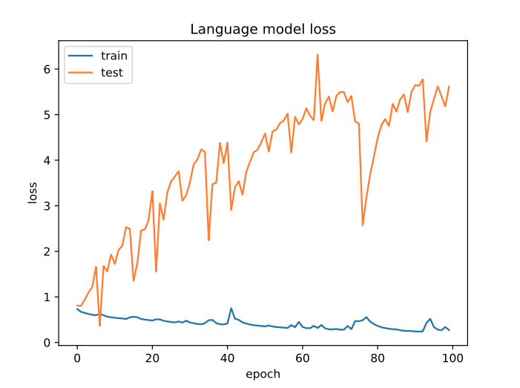

Figure : Language model loss

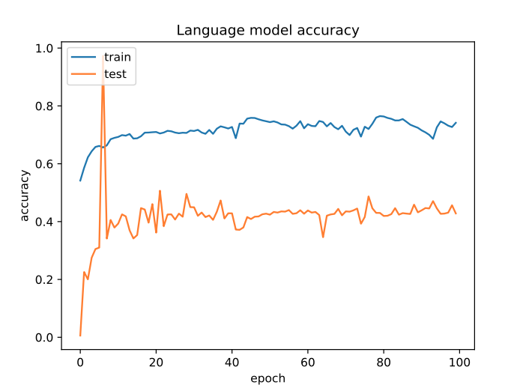

Figure 2: Language model accuracy

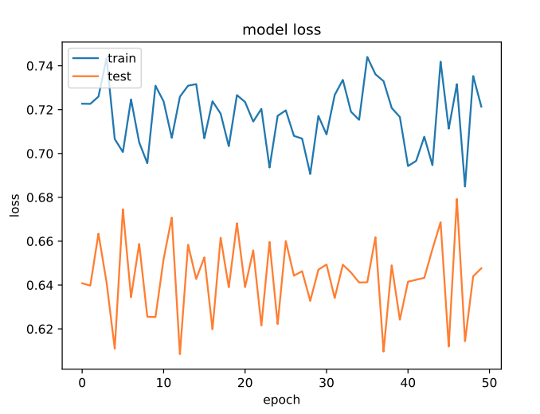

Figure : Image model loss

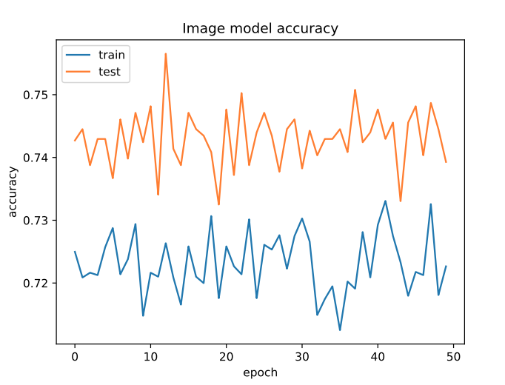

Figure : Image model accuracy

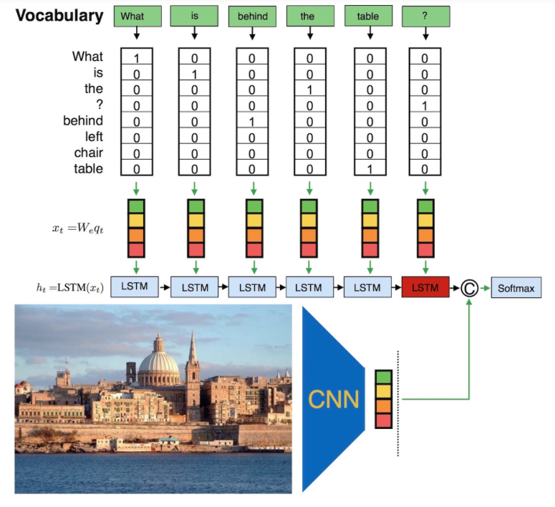

If your training data accuracy ("acc") keeps improving while your validation data accuracy ("val_acc") gets worse, you are likely in an [overfitting](https://en.wikipedia.org/wiki/Overfitting) situation, i.e. your model starts to basically just memorize the data.

The accuracies are l

.

Adding the visual data afterwards, does not help the performance compared to *combined input.*

The hypothesis of a worse performance with combining language data with visual data does hold. The model did not learn, but got more confused by the data. This can be due to the several reasons, that I will discuss below.

*4. Discussion*

The language learning is not impressing either, indicating that the model did not find a significant pattern in the tweets. A deeper semantic analysis of the sentences might reveal informative clues for the model to distinguish the classes. Training a character-based language model on another English corpus, and then use the encoded knowledge for a sentiment analysis of my data – and for the visual data too, as suggested above. This would give the model more “background knowledge” to base predictions on. The data is in itself noisy with many empty sentences and repetitions across classes.   
 Finally, if we assume to have enough and appropriate data, the way to construct the synthetic dataset can be questioned too. I chose to select the part of the corpus with the longest sentences, and then map to facial expression categories. The synthetic dataset could be expanded by mapping the same sentence to many pictures and thereby multiplying the size. This system

*5. Conclusions and further work*

Three experiments were done: one only on images, one only on language, one where a LSTM trained jointly on images and sentences. Neither of the three models performed promising: . Better performance by joining sentiment bearing sentences with facial expressions was not achieved in this setup. Further work would be to train language and image models separately and on more data. A bigger language dataset with deeper linguistic analysis would probably be beneficial. The improvements would hopefully confirm the hypothesis: My claim is still that the emotions we express generally comes with certain facial expressions, and we can use this in situated language systems. Despite insignificant results, this project was a step towards this purpose.

*6.. References*

[Richard Socher](http://www.socher.org/), [Alex Perelygin](http://nlp.stanford.edu/~aperelyg/), [Jean Wu](http://www.stanford.edu/~jeaneis/), [Jason Chuang](http://jason.chuang.info/), [Christopher Manning](http://nlp.stanford.edu/manning/), [Andrew Ng](http://cs.stanford.edu/people/ang/) and [Christopher Potts](http://www.stanford.edu/~cgpotts/): *Recursive Deep Models for Semantic Compositionality Over a Sentiment Treebank*, Conference on Empirical Methods in Natural Language Processing (EMNLP 2013) : <https://nlp.stanford.edu/sentiment/treebank.html>

I. Goodfellow, D. Erhan, P.L. Carrier, A. Courville, M. Mirza, B. Hamner, W. Cukierski, Y. Tang, D.H. Lee, Y Zhou, C Ramaiah, F. Feng, R. Li, X. Wang, D. Athanasakis, J. Shawe-Taylor, M. Milakov, J. Park, R. Ionescu, M. Popescu, C. Grozea, J. Bergstra, J. Xie, L. Romaszko, B. Xu, Z. Chuang, and Y. Bengio: "*Challenges in Representation Learning: A report on three machine learning contests."* arXiv 2013.

Francois Chollet et al.: *Keras,* onGitHub, 2015 - https://github.com/keras-team/keras

McKinney, Wes. (2010) *Pandas: a Foundational Python Library for DataAnalysis and Statistics* presented at SciPy 2010

Stéfan van der Walt, S. Chris Colbert and Gaël Varoquaux. *The NumPy Array: A Structure for Efficient Numerical Computation*, Computing in Science & Engineering, **13**, 22-30 (2011),

Sak, Haşim & Senior, Andrew & Beaufays, Françoise. (2014). Long Short-Term Memory Based Recurrent Neural Network

Architectures for Large Vocabulary Speech Recognition.

|  |
| --- |
|  |
|  |

Hochreiter, S., Schmidhuber, J.: *Long Short-Term Memory* in Neural Computation Journal, vol. 9 Issue 8, pp. 1735-1780, MIT Press Cambridge, USA, 1997

[1] : VGG16 architecture: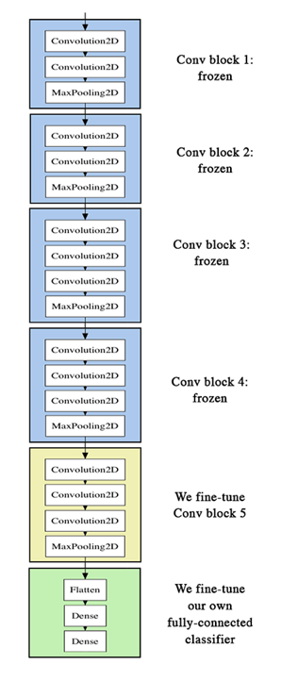

1. As here <https://blog.keras.io/building-powerful-image-classification-models-using-very-little-data.html>
2. Higher chance of getting a sentence, rather than punctuations or smileys
3. Changed from regression for simplicity.